**ASTR 257 Project 5:**

**Measuring Dark Matter in an Edge-On Galaxy**

**Overview**

By measuring the rotation curves of edge-on galaxies, Vera Rubin and her collaborators were able to show that invisible “dark” matter is ubiquitous beyond the light emitting central regions of galaxies. From Kepler’s 3rd law, rotational velocity drops off with distance from a central mass. Rubin’s measurements (Figure 1) show that the rotational velocity does not drop off, and therefore, mass must exist at large galactic radii where there is relatively little starlight.

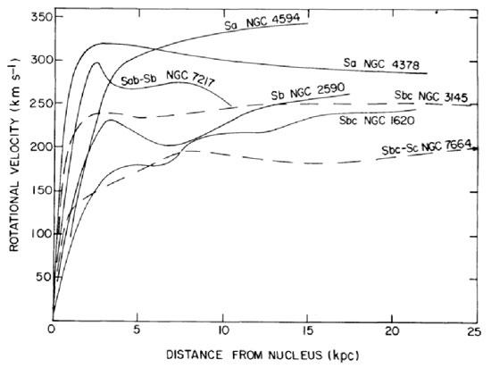

*Figure 1: Rubin et al. (1978) rotation curves of edge-on galaxies, which can be used to infer the presence of dark matter.*

We’re going to repeat Vera Rubin’s experiment for the edge-on galaxy UGC 11876 using the KAST optical spectrograph on the Shane 3-meter. There are many more free parameters for designing a spectroscopic observation than the imaging observations we’ve done in the past. During the afternoon, we will do a short exercise using KAST data so that you are familiar with the system before you plan your observations. The ultimate goal of this project will be to make a plot, similar to figure 1, for UGC 11876.

**Learning Objectives:**

* Students will learn to plan and execute spectroscopic observations with the Shane 3-meter telescope and its KAST spectrograph.
* Students will learn the basics of spectroscopic calibration and data reduction.
* Students will learn to present their observations in a standard written format that is appropriate for publication.

**Spectroscopic Data Analysis with KAST**

I have provided two fits files from the KAST spectrograph, which will help familiarize you with the system. arcs.fits is a spectrum of arc lamps that produce emission lines at known wavelengths. This will allow you to calibrate the wavelength solution of your spectrograph (i.e. what wavelength corresponds to each pixel). Solar_spectrum.fits is a spectrum of the twilight sky (i.e. scattered sunlight). Arcs.fits and Solar_spectrum.fits were obtained close in time, and without any optics in KAST being moved, which means the wavelength solution from arcs.fits can be applied to Solar_spectrum.fits.

Open the arcs file in ds9 (or Ginga) and use the projection region tool to make a quick spectrum of the arcs. You will want to do this in python eventually, but a quick look will be useful. The KAST website has images of arc lamp spectra with prominent lines labeled in wavelength:

<https://mthamilton.ucolick.org/techdocs/instruments/kast/kast_arcSpectra.html>

Find the arc lamp spectrum that corresponds to the instrument configuration of KAST. The instrument configuration can be gleaned from the FITS header. I will note here that FITS headers tend to be terse because the maximum string length was standardized in 1981 when memory was expensive. There is lots of information in the FITS header, some of which is useful and some of which is not. Now would be a good time to read through the hardware overview on the KAST webpage if you haven’t already:

<https://mthamilton.ucolick.org/techdocs/instruments/kast/hw_overview.html>

Open arcs.fits in Python and use the labeled arc lamp spectrum to wavelength calibrate arcs.fits. This will involve identifying arc lines and performing a polynomial fit to wavelength vs. pixel. Because arcs.fits was taken close in time to Solar_spectrum.fits, you can now apply your wavelength calibration to Solar_spectrum.fits and make a plot of wavelength vs. counts (as opposed to pixel number vs. counts).

Can you identify Franhofer lines? How many and which ones?

**Planning Your Observations**

***Where is UGC 11876*** ***in the Sky and When is it Observable?***

For extragalactic observations, NED is a good database for determining coordinates and other relevant information:

<https://ned.ipac.caltech.edu/>

Once you know the coordinates, determine when the galaxy is observable with KAST.

***How Will We Configure KAST for our Observations?***

Consider the slit and its configuration for Kast. What slit width will you use and why? How will you orient the slit on the galaxy?

Rubin et al. (1978) has measurements at H-alpha (6563 Angstrom), so that’s what we’ll do. Read through the KAST hardware overview and try to come up with an optimal configuration for the dichroic, grating and grating tilt (if applicable). Your first choice for a disperser or dichroic might not be available. KAST doesn’t have room to hold every optic so observatory staff change them during the day, but it’s best to make your requests a few days in advance. Note that KAST can simultaneously observe with its Blue- and Red-side, but to keep things easy, let’s just observe with one side.

Best practice is to not move optics around during the night, because then you have to recalibrate. So once you’ve individually come up with a solution, we’ll have to come to an agreement as a class.

***Choosing Integration Times***

Each group will rotate through 30-minute turns with the telescope (both for calibration and for night-time observations). If you take many short integrations, you will be limited by read-noise (think about why). If you only take one integration, a poorly placed cosmic ray could ruin all of your data.

***Calibration***

Come up with a plan for calibration. Typically, spectrograph calibrations involve wavelength calibration (which you have now done), as well as biases and flats (and darks for the near-IR).

Spectrograph flats are a little weird. Instead of flattening the whole detector, you flatten wavelength-by-wavelength, since whatever source you’re looking at probably doesn’t produce the same number of photons at every wavelength. Best practice is to use a flat light source that doesn’t have too many emission/absorption lines since each pixel is actually a mixture of wavelengths, and the pixels might not be perfectly aligned with the disperser.

**To Be Completed During the Field Trip**

Plan and execute the observations. Reduce and calibrate your data. Make your version of the plot shown in Figure 1.

**Writeup (To Be Completed After the Field Trip)**

Please write descriptions of your Observations, Reductions and Results. Your Reductions section can be part of the Observations section, or it can be its own separate section. I expect your Observations section to be publication quality, your Reductions section to be clear, but not necessarily at the level of detail seen in publications, and your Results section to be extremely brief, just presenting your version of Figure 1 and a brief description of how you made it.